صورة تحتوي على توضيح, رسوم متحركة, قصاصة فنية, التصميم

تم إنشاء الوصف تلقائياً بثقة متوسطةصورة تحتوي على دائرة, رسوم متحركة

تم إنشاء الوصف تلقائياً

Name: Shady Mohamed Abdel Gawad

ID: 20200246

Subject: Topics in Information Technology-2 (Cloud Computing)‬‏

Under the supervision of: Dr/ Nour Mahmoud

Group: S1

**Part 1 - Investigate vSphere Main Services:**

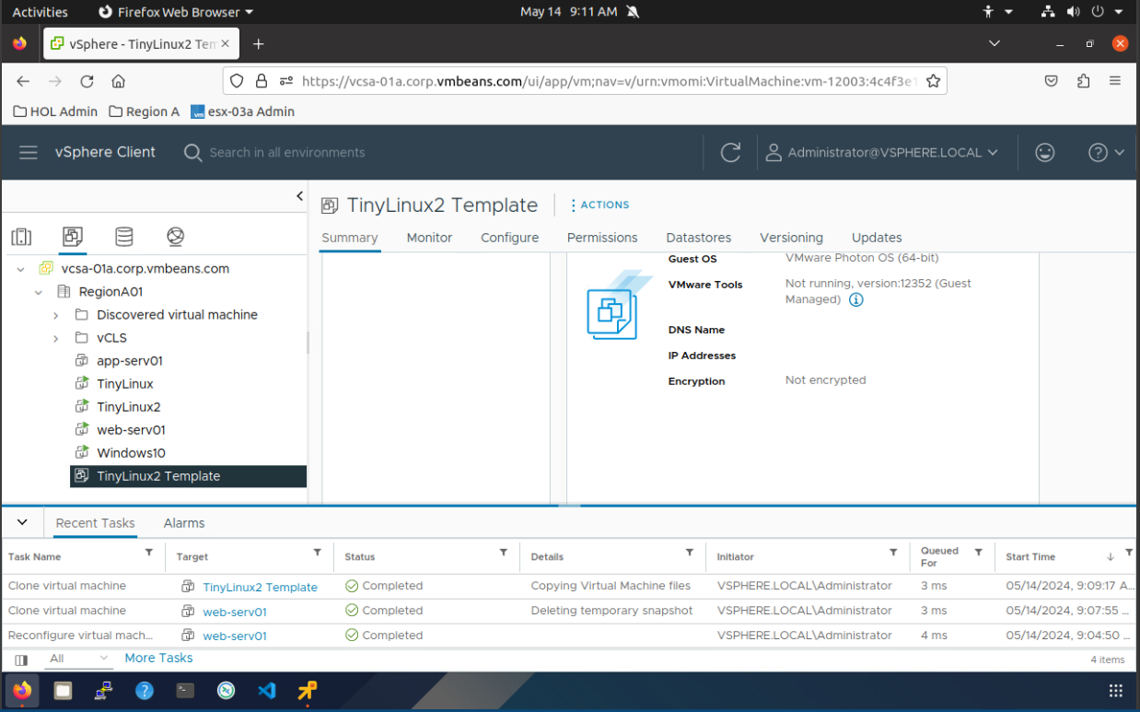

**Cloning Virtual Machines and Using Templates**

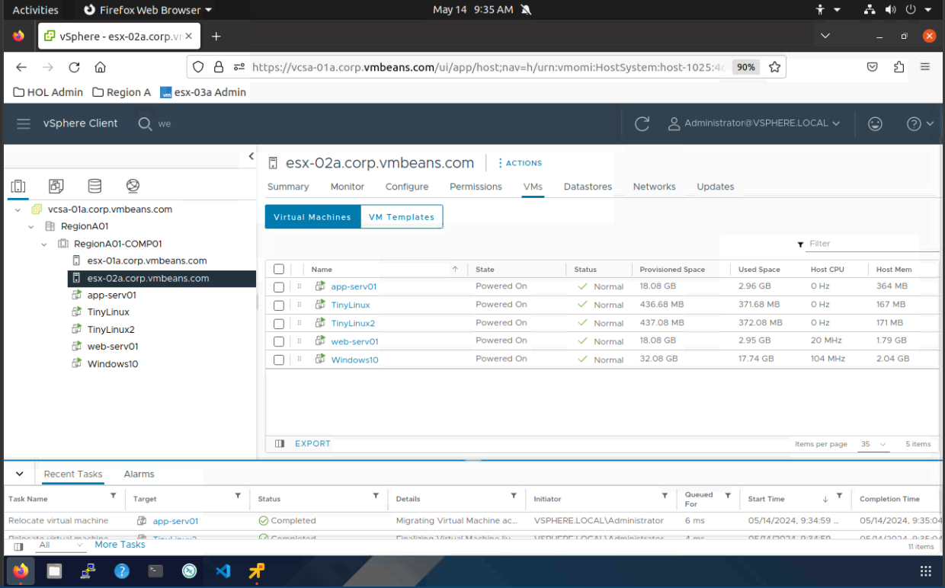**صورة تحتوي على نص, لقطة شاشة, برمجيات, أيقونة الحاسوب

تم إنشاء الوصف تلقائياً**

**Understanding vSphere High Availability and Distributed Resource**

**Scheduler (DRS)**

**Migrating Virtual Machines with VMware vMotion**

**Answer the following questions:**

1. **What is the difference between VMware vSphere High Availability**

**(HA) and DRS?**

**VMware vSphere offers two key functionalities for managing virtual machines (VMs) in a cluster environment: High Availability (HA) and Distributed Resource Scheduler (DRS). While both are essential for maintaining a healthy virtualized environment, they address different aspects:**

**vSphere HA focuses on availability. In case of a host failure, HA ensures automatic restart of affected VMs on remaining cluster hosts. This minimizes downtime for critical applications running on those VMs.**

**vSphere DRS concentrates on resource optimization. It dynamically migrates VMs across cluster hosts based on resource utilization. This helps balance workloads, prevent resource bottlenecks, and improve overall cluster efficiency.**

**Here's an analogy: Imagine a hospital with multiple operating rooms (cluster hosts).**

**HA acts like a backup surgical team. If the primary surgeon (host) becomes unavailable, the backup team (HA) ensures the surgery (VM operation) continues on another operating table (different host) with minimal disruption.**

**DRS functions like an OR manager. It distributes patients (VMs) across operating rooms (hosts) based on their needs and the surgeons' (hosts') capacity. This ensures efficient utilization of all available operating rooms.**

**In essence, HA safeguards VM uptime during host failures, while DRS optimizes resource allocation for smooth VM operation. They work together seamlessly to provide a robust and efficient virtualized environment.**

1. **What is FDM and what is its rule in vSphere HA?**

**FDM stands for Fault Domain Manager. It's a critical component within vSphere HA, playing a key role in ensuring VM availability during host failures. Here's how FDM functions:**

**Agent on Every Host: FDM operates as a software agent. It runs on each ESXi host participating in the vSphere HA cluster.**

**Communication Hub: FDM acts as a communication hub between ESXi hosts. It facilitates the exchange of information regarding:**

**Available resources on each host (CPU, memory, storage)**

**Status of running VMs (powered on, powered off, suspended)**

**vSphere HA configuration details**

**Master Election: The FDM agents elect a single host as the "master" within the cluster. This master plays a crucial role in coordinating HA activities.**

**Heartbeat Monitoring: FDMs on all hosts constantly exchange heartbeats. This allows them to detect host failures promptly.**

**VM Restart Decisions: Upon detecting a host failure, the FDM master leverages the collected information to determine which VMs need restarting and where to restart them on remaining healthy hosts.**

**vCenter Server Interaction: While FDM agents handle communication and coordination within the cluster, they also interact with vCenter Server. vCenter Server provides overall management and configuration of vSphere HA, including FDM settings.**

**In simpler terms, FDM acts as the nervous system of vSphere HA. It constantly monitors the health of ESXi hosts, detects failures, and coordinates the automatic restart of VMs on surviving hosts. This ensures minimal downtime for your virtual machines during host-related issues.**

1. **What are the automation levels in DRS and what is their function?**

**DRS, or Distributed Resource Scheduler, in vSphere offers three automation levels for managing VM migrations within a cluster:**

**1. Manual:**

**In this mode, DRS acts purely as an advisor.**

**It analyzes resource utilization across cluster hosts and identifies potential imbalances.**

**DRS recommends VM migrations to optimize resource allocation but doesn't execute them automatically.**

**The administrator has to manually review these recommendations and decide whether to initiate migrations.**

**2. Partially Automated:**

**This mode offers a balance between automation and control.**

**DRS can automatically perform initial placement of VMs during deployment based on predefined rules and cluster configuration.**

**However, for existing VMs, DRS still recommends migrations for load balancing but requires manual approval before execution.**

**This allows administrators to maintain some oversight while benefiting from DRS's automated analysis and placement for new VMs.**

**3. Fully Automated:**

**This mode provides the most hands-off approach.**

**DRS takes complete control over VM migrations for both initial placement and load balancing.**

**Based on configured thresholds and DRS rules, it can automatically migrate VMs across cluster hosts to optimize resource utilization without requiring manual intervention.**

**This offers the highest level of automation but requires careful configuration of DRS thresholds and rules to ensure migrations align with your cluster's performance and resource requirements.**